Ringmaster Fly-A-Thon 2025
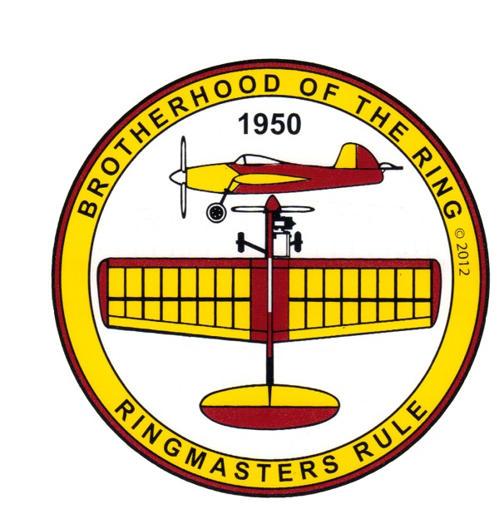
The Brotherhood of the Ring is sponsoring its 18th Annual Fly-A-Thon event:
LCRCC is participating on Monday October 6th, 2025
LCRCC Rain Date on Wednesday October 8th, 2025
Flying Time: 8:30-2:00 pm
RC Flying will NOT be possible during this event

We dedicate this Flyin to the memory of Jeff Troy, our Controline Squadron Member.
Matt Kania’s beloved Ringmaster control line model has been built and flown by more modelers than any other control line model airplane!
Worldwide Goal this year is smash the 11,164+ flights by 700+pilots!

LCRCC Goal this year is 500 flights and 4,000 Laps by 16+ pilots!
(500 Flights x 8 laps per Flight equals 4K Laps)

Any Ringmaster from 1/2A to Giant and all variants in between can be flown.

Lunch Menu:
Hot Dogs, Chips, Cookies & Soda

Ron Howe
Event Director
kb4rqm@gmail.com

